**Modello Cards**

Vedremo

* Valutazione Modello

1. Performance Modello
2. Analisi Variabili pù importanti

Mi sono scaricato alcune librerie che si sono creati loro:

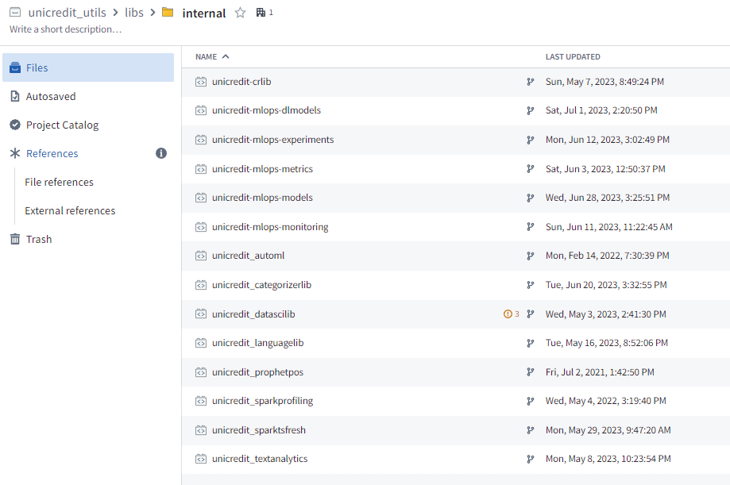

**Valutazione Modello**

Le loro analisi Relative al modello di cards si trovano in:

[**https://foundry.intranet.unicredit.eu/workspace/contour-app/ri.contour.main.analysis.2857e9b0-6bfc-4f60-91db-9b1467072bbd/path/ri.contour.main.ref.5d4c5aac-d27a-4652-a484-df06409075e2/board/db36813d-8aa1-3771-9ce1-43ea1edba87a?viewMode=edit**](https://foundry.intranet.unicredit.eu/workspace/contour-app/ri.contour.main.analysis.2857e9b0-6bfc-4f60-91db-9b1467072bbd/path/ri.contour.main.ref.5d4c5aac-d27a-4652-a484-df06409075e2/board/db36813d-8aa1-3771-9ce1-43ea1edba87a?viewMode=edit)

Mi sono salvato il dataset in cui Adriana ha applicato i modello nel repository in UR00601:





E mi sono fatto un Contour **Analisi_risultati** dove analizzo questa tabella:

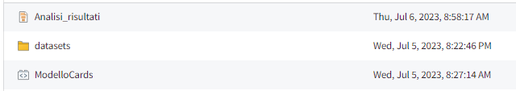

1. **Performance Modello**
2. La prima cosa loro hanno tanti snapshot ,**verificano la probabilità media se è sempre uguale** all’incidenza della variabile target , e se non ci sono distorsioni:

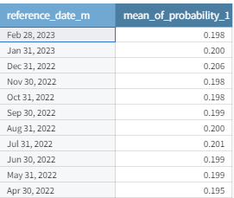

Come vedi la media della probabiità è uguale in tutti gli snpashot ed è circa il 19% che è l’incidenza della variabile target che è il 17%.

1. La seconda cosa da vedere è se **Auc è uguale per tutti snapashot**

from pyspark.sql import functions as F

from transforms.api import transform_df, Input, Output

from pyspark.sql import types as T

from pyspark.sql.types import *

import pandas as pd

@transform_df(

    Output("/Users/UR00601/Modelli_Gruppo_Barardi/cards/datasets/Z01_Application/A001A02_Performance_01"),

    df=Input("/Users/UR00601/Modelli_Gruppo_Barardi/cards/datasets/Z01_Application/A001A01_Modello_Applicato"),

)

def compute(df):

    date_col = 'reference_date_m'

    target_col = 'target'

    prediction_col = 'probability_1'

    df = (

        df

        .select(

            'reference_date_m',

            'target',

            'probability_1',

            'test_type',

            'consent'

        )

    )

    udf_out_schema = T.StructType(

        [

            T.StructField(date_col, T.DateType(), False),

            T.StructField('auc', T.FloatType(), True),

        ]

    )

    # pandas_udf

    def pd_udf(group):

        import pandas as pd  # noqa

        from sklearn.metrics import roc_auc_score

        if group[target_col].sum() > 1:

            auc = roc_auc_score(group[target_col], group[prediction_col])

        else:

            auc = None

        results_df = pd.DataFrame(

            [

                {

                    date_col: group[date_col].values[0],

                    'auc': auc

                }

            ]

        )

        return results_df

    results_df = df.groupby(date_col).applyInPandas(pd_udf, udf_out_schema)

    return results_df

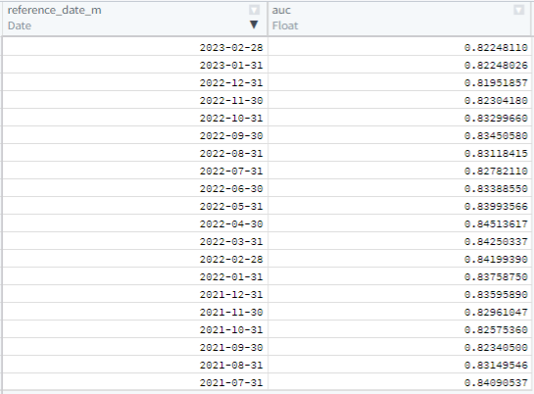

**Come vedi è costante nel tempo.**

**Tutte le altre le metriche con calcolo Uplflit**

Vengono calcolati tutti gli ndicatori in questa query:

def unnamed(inference_lgbm_hyperopt_featImp_quantilePerf):

    n_col = "n"

    ref_dt = 'reference_date_m'

    target_col = 'target'

    true_positives_col = "true_positives"

    n_cut_col = "n_cut"

    cum_true_positives_col = "cum_true_positives"

    percent_rank_col = "percent_rank"

    temp_percentile_col = "percentile_"

    percentile_col = 'percentile'

    quantile_granularity = 100

    recall_col = 'recall'

    precision_col = 'precision'

    f1_col = 'f1_score'

    uplift_col = 'uplift'

    baseline_incidence = 'baseline_incidence'

    overall_samples = 'overall_ndgs'

    overall_pos = 'overall_pos'

    df = (

        inference_df

        .select(

            'ndg',

            ref_dt,

            target_col,

            prediction_col,

            F.percent_rank().over(Window.partitionBy('reference_date_m').orderBy(prediction_col)).alias(percent_rank_col),

        )

        .withColumn(temp_percentile_col,(F.col(percent_rank_col) * quantile_granularity).cast(IntegerType()))

        .withColumn(percentile_col,

            F.when(

                F.col(temp_percentile_col) == quantile_granularity,

                F.lit(quantile_granularity - 1),

            ).otherwise(F.col(temp_percentile_col)),

        )

        .drop(temp_percentile_col)

    )

    percentile_counts = (

        df

        .groupby(ref_dt, percentile_col)

        .agg(

            F.count("*").alias(n_col),

            F.sum(F.col(target_col)).alias(true_positives_col)

        )

    )

    w = Window.partitionBy(ref_dt).orderBy(F.desc(percentile_col))

    w_date = Window.partitionBy(ref_dt)

    metrics_df = (

        percentile_counts

        .withColumn(n_cut_col, F.sum(F.col(n_col)).over(w))

        .withColumn(

            cum_true_positives_col, F.sum(F.col(true_positives_col)).over(w)

        )

        .withColumn(

            recall_col, F.col(cum_true_positives_col) / F.sum(F.col(true_positives_col)).over(Window.partitionBy(ref_dt))

        )

        .withColumn(

            precision_col, F.col(cum_true_positives_col) / F.col(n_cut_col)

        )

        .withColumn(

            f1_col,

            2.0

            * (F.col(precision_col) * F.col(recall_col))

            / (F.col(precision_col) + F.col(recall_col)),

        )

        .withColumn(overall_samples, F.sum(F.col(n_col)).over(w_date))

        .withColumn(overall_pos, F.sum(F.col(true_positives_col)).over(w_date))

        .withColumn(baseline_incidence, F.col(overall_pos)/F.col(overall_samples))

        .withColumn(uplift_col, F.col(precision_col)/F.col(baseline_incidence))

        .orderBy(F.col(percentile_col).desc())

    )

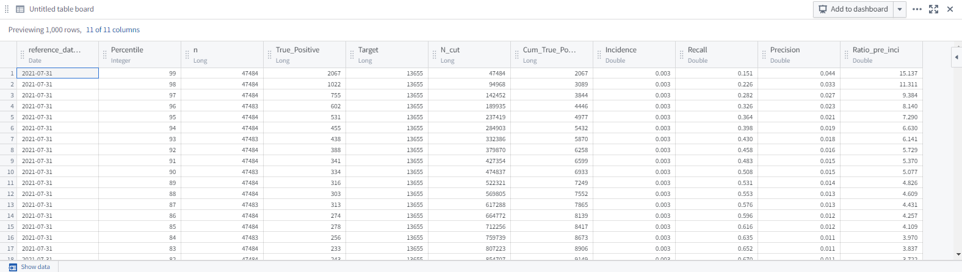

**Qui è excel scaricato** 

**E da qui parte upfilt**

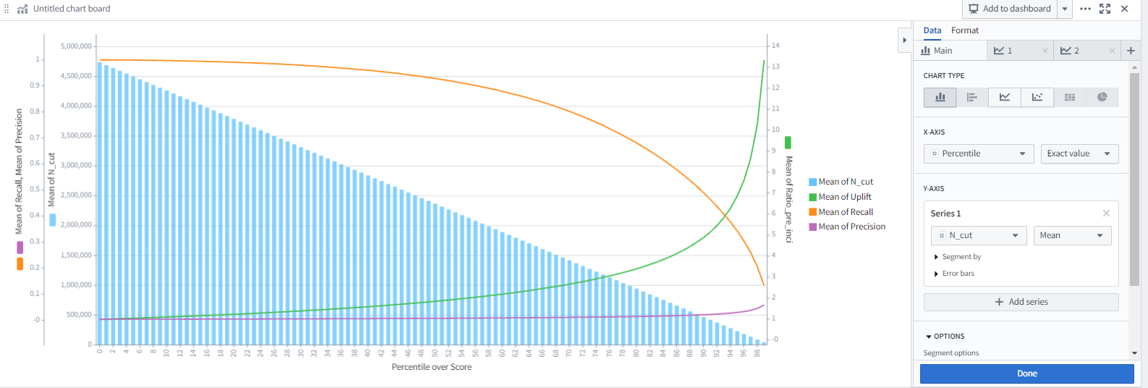

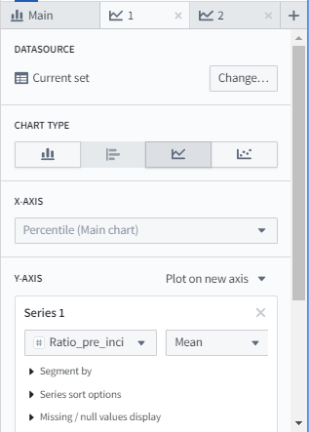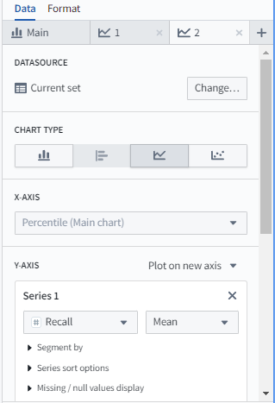

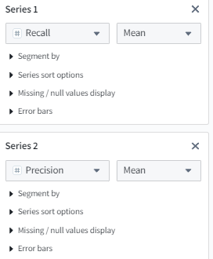

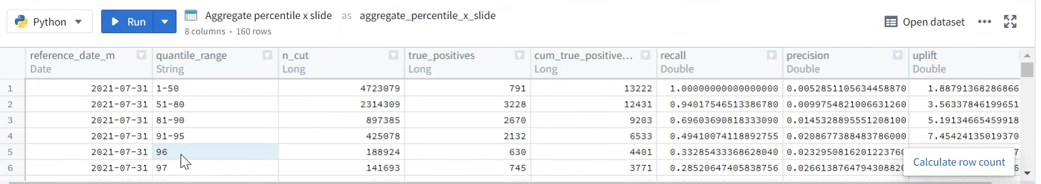

**Funzioni che calcolano il dataset :**

# Functions defined here will be available to call in

# the code for any table.

from pyspark.sql import Window, functions as F

from pyspark.sql import types as T

from pyspark.sql.types import *

import matplotlib.pyplot as plt

import numpy as np

import lightgbm as lgb

from sklearn.model_selection import train_test_split

from pyspark.ml.feature import QuantileDiscretizer

import datetime

import itertools

from sklearn.metrics import auc, precision_recall_curve, recall_score, precision_score, roc_auc_score

import pickle

import pandas as pd

Q = 90

METRICS = [

    'recall',

    'precision',

    'baseline_uplift',

    'target_uplift'

    ]

schema = StructType(

        [

            StructField('reference_date_m', DateType(), False),

            StructField('partition', StringType(), False),

            StructField(f'{Q}_quantile_recall', FloatType(), True),

            StructField(f'{Q}_quantile_precision', FloatType(), True),

            StructField('auc', FloatType(), True),

            StructField('detected_positives', IntegerType(), False),

            StructField('tot_positives', IntegerType(), False),

            StructField('mean_target', FloatType(), False),

            StructField('mean_pred', FloatType(), False),

            StructField('count', IntegerType(), False),

            StructField(f'{Q}_count', IntegerType(), True)

        ]

    )

# PandasUDF that trains the lgb Classifier on a specific fold, on the train partition and the applies on the val set

def evaluate_fold(group):

    from sklearn.metrics import roc_auc_score

    import pandas as pd  # noqa

    group = group.sort_values('pred')

    # create a (unique) ranking columns that follows the sorting computed above

    group['rank'] = range(group.shape[0])

    # Compute quantiles over the ranking column, in order to group the predictions

    group['quantile'] = pd.qcut(group['rank'], 1000, labels=False)

    if group['target'].sum() > 1:

        auc = roc_auc_score(group['target'], group['pred'])

    else:

        auc = None

    mean_target = group['target'].mean()

    mean_pred = group['pred'].mean()

    # Compute metrics with such support:

    # Detected Positive: all the samples included in the top quantile(s)

    # True Positive: all the samples with target = 1 in the top quantile(s)

    # Tot Positive: all the samples with target = 1 in the validation set

    tot_pos = group['target'].sum()

    best_quantile = group[group['quantile'] >= Q]['target']

    detected_pos = best_quantile.sum()

    # Recall = Detected Positive / Tot Positive

    recall = detected_pos / tot_pos

    # Precision = True Positive / Detected Positive

    precision = best_quantile.mean()

    results_df = pd.DataFrame(

        [

            {

                'reference_date_m': group['reference_date_m'].values[0],

                'partition': group['partition'].values[0],

                f'{Q}_quantile_recall': recall,

                f'{Q}_quantile_precision': precision,

                'auc': auc,

                'detected_positives': detected_pos,

                'tot_positives': tot_pos,

                'mean_target': mean_target,

                'mean_pred': mean_pred,

                'count': group.shape[0],

                f'{Q}_count': len(best_quantile)

            }

        ]

    )

    return results_df

def AUPRC(y_true, y_pred, pos_label=1):

    precision, recall, _ = precision_recall_curve(y_true, y_pred, pos_label=pos_label)

    return auc(recall, precision)

def AUPRC_lgbm(y_true, y_pred):

    '''

    https://lightgbm.readthedocs.io/en/latest/pythonapi/lightgbm.LGBMClassifier.html

    Custom eval function expects a callable with following signatures:

        - func(y_true, y_pred)

        - func(y_true, y_pred, weight)

        - func(y_true, y_pred, weight, group)

    returns:

        - (eval_name: str, eval_result: float, is_higher_better: bool)

        - list of (eval_name: str, eval_result: float, is_higher_better: bool)

    '''

    return 'AUPRC', AUPRC(y_true, y_pred), True

def metrics_backbone_calculation(inference_df, prediction_col):

        n_col = "n"

        ref_dt = 'reference_date_m'

        target_col = 'target'

        true_positives_col = "true_positives"

        n_cut_col = "n_cut"

        cum_true_positives_col = "cum_true_positives"

        percent_rank_col = "percent_rank"

        temp_percentile_col = "percentile_"

        percentile_col = 'percentile'

        quantile_granularity = 100

        recall_col = 'recall'

        precision_col = 'precision'

        f1_col = 'f1_score'

        uplift_col = 'uplift'

        baseline_incidence = 'baseline_incidence'

        overall_samples = 'overall_ndgs'

        overall_pos = 'overall_pos'

        df = (

            inference_df

            .select(

                'ndg',

                ref_dt,

                target_col,

                prediction_col,

                F.percent_rank().over(Window.partitionBy('reference_date_m').orderBy(prediction_col)).alias(percent_rank_col),

            )

            .withColumn(temp_percentile_col,(F.col(percent_rank_col) * quantile_granularity).cast(IntegerType()))

            .withColumn(percentile_col,

                F.when(

                    F.col(temp_percentile_col) == quantile_granularity,

                    F.lit(quantile_granularity - 1),

                ).otherwise(F.col(temp_percentile_col)),

            )

            .drop(temp_percentile_col)

        )

        percentile_counts = (

            df

            .groupby(ref_dt, percentile_col)

            .agg(

                F.count("*").alias(n_col),

                F.sum(F.col(target_col)).alias(true_positives_col)

            )

        )

        w = Window.partitionBy(ref_dt).orderBy(F.desc(percentile_col))

        w_date = Window.partitionBy(ref_dt)

        metrics_df = (

            percentile_counts

            .withColumn(n_cut_col, F.sum(F.col(n_col)).over(w))

            .withColumn(

                cum_true_positives_col, F.sum(F.col(true_positives_col)).over(w)

            )

            .withColumn(

                recall_col, F.col(cum_true_positives_col) / F.sum(F.col(true_positives_col)).over(Window.partitionBy(ref_dt))

            )

            .withColumn(

                precision_col, F.col(cum_true_positives_col) / F.col(n_cut_col)

            )

            .withColumn(

                f1_col,

                2.0

                * (F.col(precision_col) * F.col(recall_col))

                / (F.col(precision_col) + F.col(recall_col)),

            )

            .withColumn(overall_samples, F.sum(F.col(n_col)).over(w_date))

            .withColumn(overall_pos, F.sum(F.col(true_positives_col)).over(w_date))

            .withColumn(baseline_incidence, F.col(overall_pos)/F.col(overall_samples))

            .withColumn(uplift_col, F.col(precision_col)/F.col(baseline_incidence))

            .orderBy(F.col(percentile_col).desc())

        )

        return metrics_df

Questo è il dataset



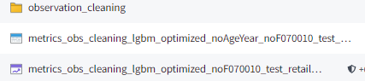

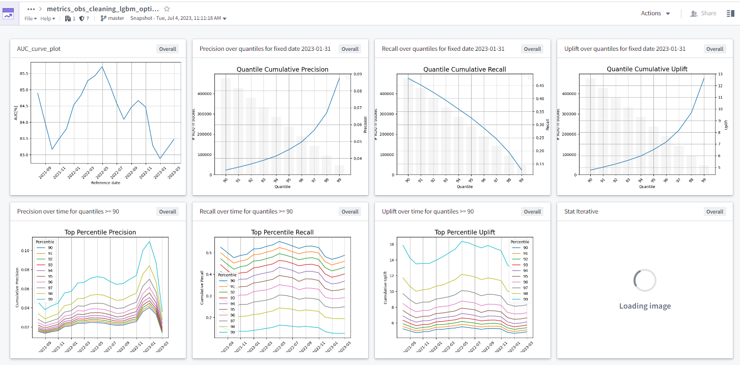

1. **Analisi delle variabili più importanti:**

La variabile più importante del modello è:

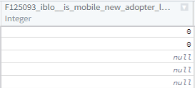

La prima cosa da vedere è la distribuzione nei vari mesi:

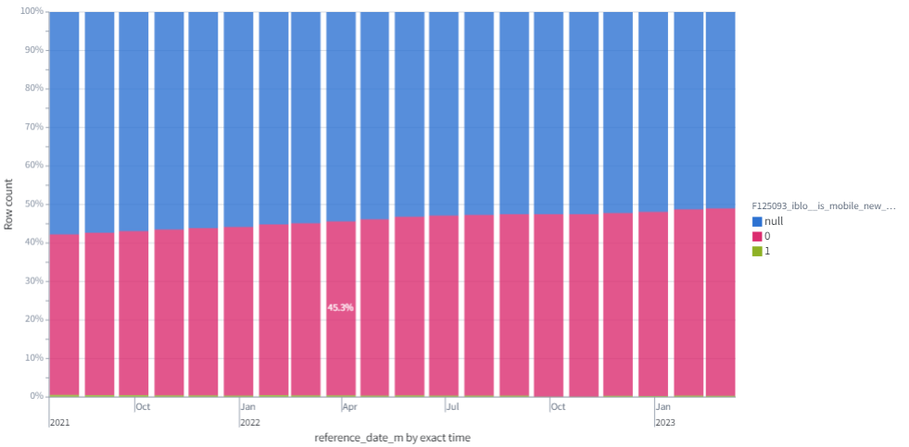

La seconda cosa da vedere è la distribuzione di questa variabile con la variabile **target**

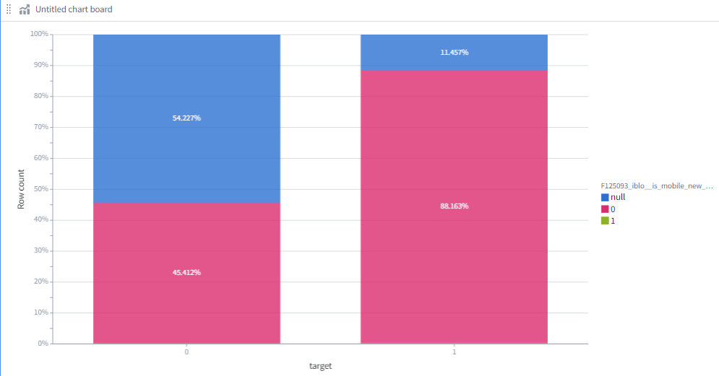

Importante se ti calcoli anche gli **shap values** ,puoi farti i grafici anche tipo Laura:

esempio ho la variabile età , la bachettizzo:

**CASE** **WHEN** F008532_cntp__age_years >=18 **AND** F008532_cntp__age_years <26 **THEN** '18-25'

**WHEN** F008532_cntp__age_years >=26 **AND** F008532_cntp__age_years <35 **THEN** '26-35'

**WHEN** F008532_cntp__age_years >=36 **AND** F008532_cntp__age_years <51 **THEN** '36-50'

**WHEN** F008532_cntp__age_years >=51 **AND** F008532_cntp__age_years <66 **THEN** '51-65'

**WHEN** F008532_cntp__age_years >=66 **AND** F008532_cntp__age_years <81 **THEN** '66-80'

**ELSE** 'Over 80' **END**

Ho la relativa variabile con i valori shap che è SHAP_F008533_cntp__birth_date_y

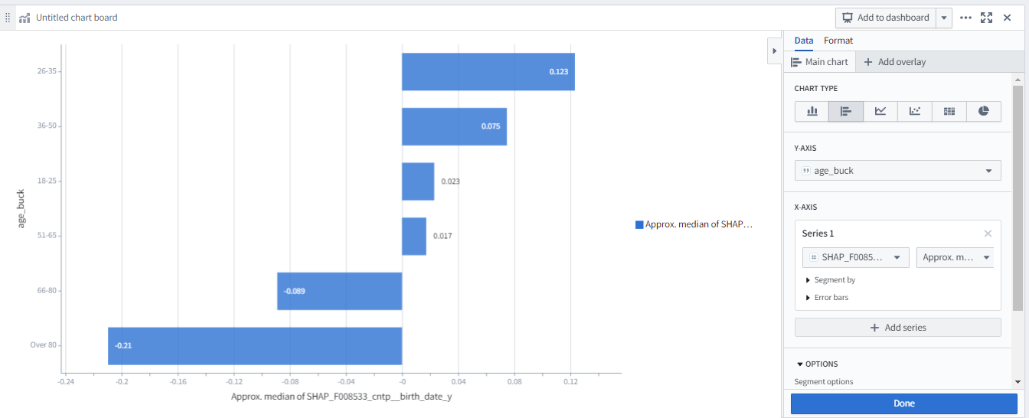

E fai l’approx median